Supplement: an experiment a bit more sophisticated.

1/ Measure and calculation of the Solar Constant.

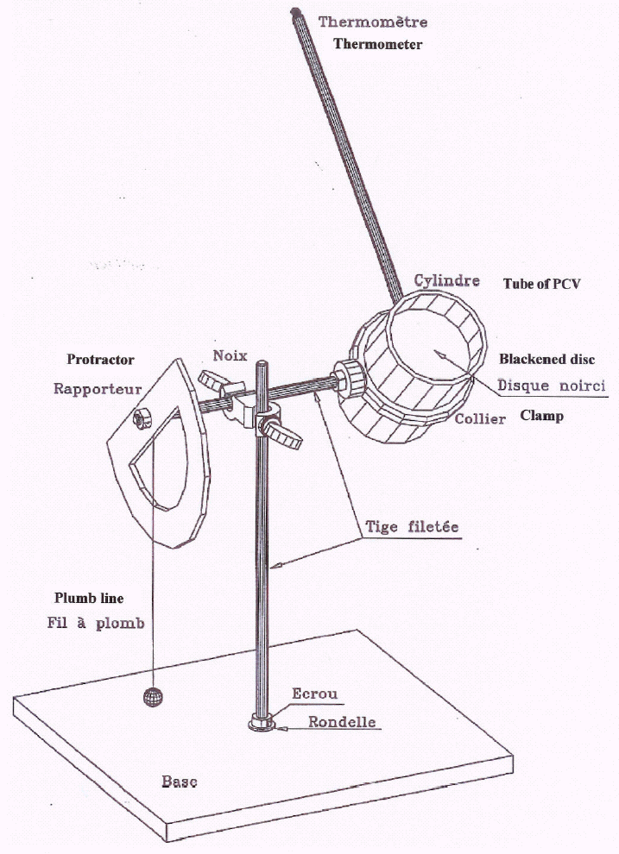
We shall use a device (fig.1) constituted by a small metallic disc insulated with a tube of PCV and a disc of polystyrene, so that the lost of heat will be as small as possible.
The metallic disc is painted in black to absorb all the energy which is coming on it; a disc of glass covers the tube to avoid the lost of infrared radiations emitted by the heated disc. A thermometer, placed in a hole made in the disc, gives its temperature.
The tube is oriented to the sun, the extremity of the tube will be covered by an sheet of aluminium until the temperature of the disc is stabilized; the protractor gives us the altitude of the sun above the horizon.

The time of exposure to the sun must be sufficient to have a variation of temperature of some degrees, but not too long because when the temperature of the disc is too high, the loss of energy through the tube is important.

The solar constant is calculated in the same way than above. The mass (m) of the disc, its radius and its caloric capacity (c) are written on it.

The metallic disc received the energy: Q = m.C.(θ_{f} – θ_{i}). (m: mass; C: calorific capacity; θ: temperature)
The solar constant is: P = Q/s.t (s: surface of the disc πr²; t: duration of the experiment)

2/ Calculation of the energy received out of the atmosphere.

The solar energy is, in part, absorbed by the atmosphere of the Earth. This loss of energy depends on the distance which is covered by the sunbeams and on the limpidity of the atmosphere.
We suppose that the atmosphere has a determined thickness h and a uniform limpidity.
To calculate the energy received out of the atmosphere we have to make several measures with different altitudes (z) of the sun and some mathematics ! (Fig. 2 and 3).

Sun
thermometer
Angle z
Sun
0

x
h
x + dx
atmosphere
z

Fig.3
Fig.2

The energy received every second of time, at the abscise x is P(x). We suppose that the loss of energy, between x and x + dx is proportional to the energy P(x).

dP(x) = - k.P(x).dx => dP(x)/P(x) = -k.dx => ∫dP(x)/P(x) = ∫- k.dx
- LnP(x) – LnP(0) =- k.x
- P(o) corresponding to x = 0, out of the atmosphere.

x depends on the angle z and the thickness (h) of the atmosphere: x = h/cos(z); k depends on the limpidity of the atmosphere.

- LnP(x) is a linear function of h/cos(z). It is Bouguer’s law. (Fig.4)
h is unknown, but supposed to be the same for every measure and so, it only introduce a modification on the scale of the abscise.

With an extrapolation to h = 0, we obtain the value of the solar constant out of the atmosphere.

We can then calculate the temperature of the Sun as made above, with Stefan-Boltzman law.

h/cos(z₁)
h/cos(z₂)
h/cos(z₃)
h/cos(z)
0
LnP₃
LnP₂
LnP₁
LnP
LnP₀

Fig.4

Bibliography :
Proceedings of the Summer Schools of the CLEA (France)

