

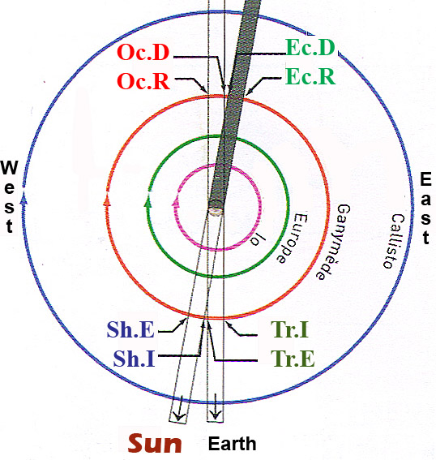 | Orbital period (d)  Ío I 1,77 - Europa II 3,55 - Ganímedes III 7,16 - Calisto IV 16,69  An occultation or eclipse begins when the satellite disappears (D)  and ends when it reappears (R).  A transit or shadow passage begins at ingress (I) and ends at egress (E)  - Oc for an occultation of the satellite behind Jupiter’s limb:  Oc.D, Oc.R  - Ec for an eclipse by Jupiter’s shadow : Ec.I, Ec.E  - Tr for a transit of the satellite across the planet’s face : Tr.I, Tr.E  - Sh for the satellite casting its tiny black shadow onto Jupiter:  ShI, ShE
The goal: To find the longitude with Jupiter’s satellites: How to measure the longitude according to Galileo’s method? We are going to calculate the longitude of La Serena according to Greenwich’s meridian or beetween two La Serena and Lyon, France.

Method with the software “Stellarium”:
1) The angle of vision (FOV: field of view) is 0.24°. In the Location window choose the city of La Serena on October, 15th. Search what time it is for the beginning of Io’transit ( I Tr.I) (Search approximately 11pm o’clock). Write it 23:….min. Search what time it is when the sun is crossing the meridian.
Write it (approximately at 12 o’clock), 12h…..min.
Search what time it is for the end of the Io’s transit (I Tr.E)

2) Now choose the town of Lyon. Do the same observation: what time is it when Io is before Jupiter? Write it ..h….min, is it the same? …………
At what time the sun is at the south. Write it …h….min, is it the same?

3) Convert the hour in minutes:
- Hour of Io’s beginning transit (I Tr.I)at La Serena ……min
- Hour of Io’s beginning transit (I Tr.I) at Lyon ……min
- When the sun is crossing the meridian at La Serena ……min
- When the sun is crossing the meridian at Lyon ……min

4) Make the difference between the moment when the sun is crossing the meridian and I Tr.I
Write it …… min, we call this measure T₁.
Start again at Lyon. Write it …… min, we call this measure T₂.

5) Make this calculation: T₂-T₁= ……-……=……min, we call this result T_{f}

6) The earth rotates (360°) around itself in 1436 min, so with a cross multiplication we can make this calculation: (T_{f} *360)/1436=……°
So There is a difference of……..degrees of longitude between La Serena and Lyon

Ephemerides: These predictions are courtesy IMCCE / Paris Observatory Oct. 16: -2:48 I.Tr.I -3:26 I.Sh.I -5:02 I.Tr.E
-5:40 I.Sh.E -17:29 III.Tr.I -20:03 III.Sh.I -20:25 III.Tr.E -21:49 II.Tr.I -23:03 III.Sh.E -23:05 II.Sh.I
Universal Time http://www.skyandtelescope.com/observing/objects/planets/38135094.html

